Primary English for China Book 10 Unit 3
Changes in our city教学设计
深圳市福田区福田小学 蔡佳韵
【教学内容】
教材：深港版小学英语教科书第十册第三单元I部分 Changes in Shenzhen
教学对象：小学五年级学生
【教学目标】
1.认知目标:
1) 能阅读理解I部分文章，并阅读相关类型篇章；
2) 能根据所给图片并根据所给时间谈论过去的事物;
3) 能对比there be结构的过去式和一般现在式。
2.能力目标:
1) 运用相关阅读技巧阅读,在理解文章的基础上正确完成练习;
2) 能模仿阅读篇章的结构完成写作。
3.情感目标:
1) 培养学生小组合作精神，做到互帮互助，以优扶差；
2) 培养关心时事，培养环保意识;
【教学重难点】
- there be 句型过去式及一般现在时的运用
tall building, highway, subway, tunnel, bridge, shopping malls, farmland, small houses, ShennanRoad, Dongmen, Yantian Harbour, Window of World,
【教学准备】
1）minibook 2) PPT 3）video 4) 深圳及本校的老旧图片
【教学过程】
Step 1: Lead-in
- Show the old and new photos of Luohu District. Tell students to find out the similarities between two pictures. (Whether they can find out is not important.) Tell them “We can see that the city changes a lot.”
- (Every student has their minibooks.) Let us watch the video first, and then make the things appearing in both the video and minibooks.
- Check within groups.
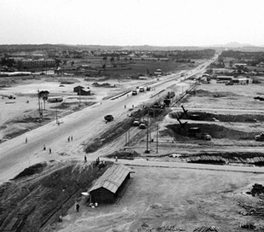
- ONE group do presentation: show their minibooks and say “There is/are…/ There isn’t/ There aren’t…”

Step 2: Guessing game
- Teacher tells students that I have an old photo of the same place. Please guess what was/were there 20 years ago. Invite ONE group stand on the stage and face to the students. Show the WHOLE photo to the rest of the class.
The students on the stage ask one by one, “Was/ Were there…?”
- Students on the seats will answer them.
There were a few people. There were not many cars. There were a few houses. There were large lands.

Step 3: Sharing
- Each group of students will get one picture. There are 8 photos for 4 places (4 new and 4 old). Students try to describe “There was/were, There is/are” and WRITE DOWN the sentences. (Students just fill in the blanks according to the picture and given words.)
- EIGHT groups do presentation (disordered): show their writing, read and then stick them on the board.

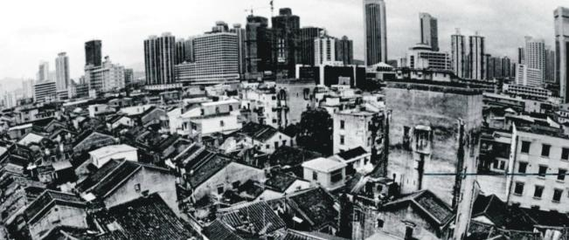
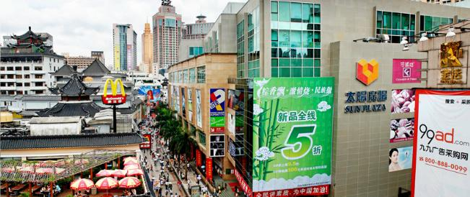
DONGMEN, 20 YEARS AGO DONGMEN, NOW
There were many small houses. People lived there.
Now, there are many shopping malls. People go shopping there.
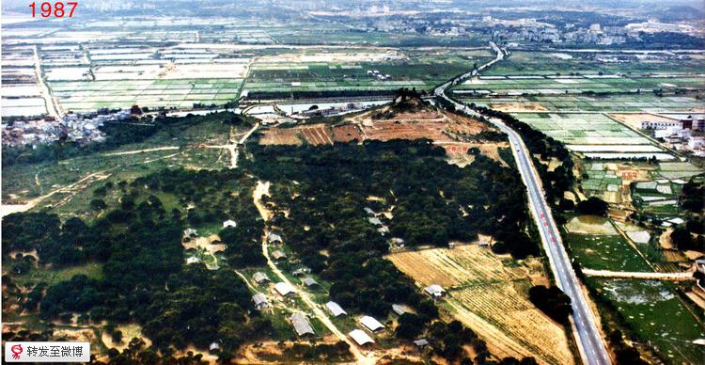
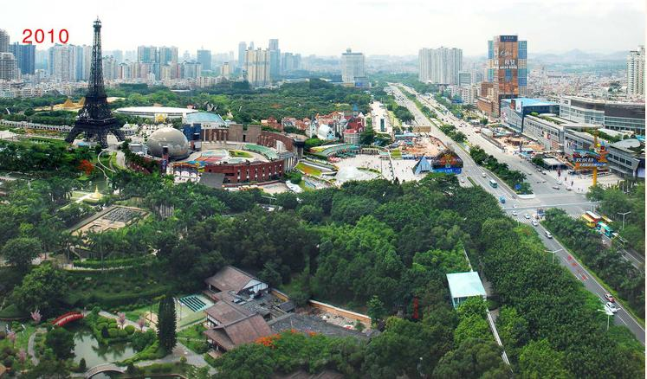

WINDOW OF WORLD, 20 YEARS AGO W of W, NOW
There were many trees. There was one small road. There were not many cars.
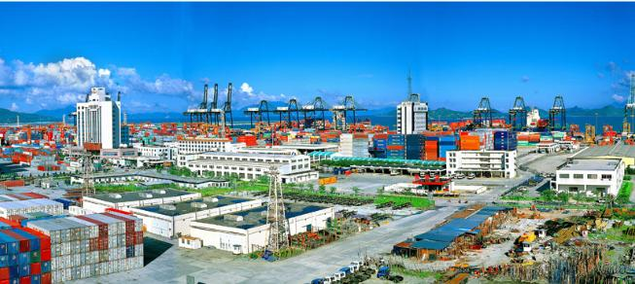
Now, there is the Window of the World. There are many cars on the road. Many people go there and have fun.
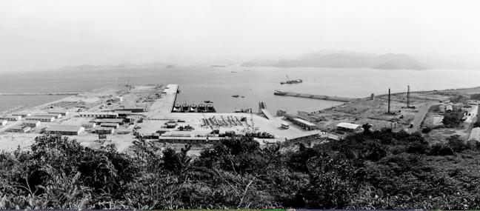

YANTIAN HARBOR, 10YEARS AGO YANTIAN HARBOR, NOW
There were no tall buildings. There were a few ships.
Now there are many buildings. There are a lot of ships.

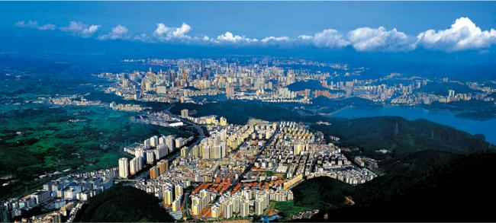
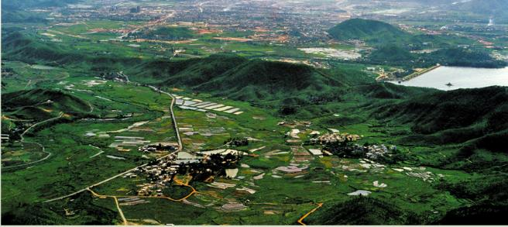

LULUOHU, 2O YEARS AGO LUOHU, NOW
There were no tall buildings. There were many farmlands. There were many small roads.
Now, there are many tall buildings. There are a lot of people. People likes living here.

Step 4: RE-READING
Re-reading the sentences, and make it a passage.

